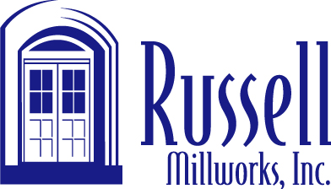

653 Buford Highway Buford, Georgia 30518 tel .(800) 841-2528 fax 770 945-0820
Important 401(k) Plan Information
Russell Mill Works Inc 401(k) Profit Sharing Plan & Trust

Russell is often called upon to assist in restoration or renovation projects. With extensive experience, they are able to faithfully duplicate architecture from the past, or renew it with energy efficient materials and technology for a new start on the future.

Many of their projects are the result of people staying in their homes longer in recent times, and their desire to update what is there to modern trends and styles. A conversion of a sliding patio door to an in or outswing French door unit is a good example. Another is re-purposing of existing space, residential or commercial, where nonstandard windows or doors are called for.

Historical preservation and restoration demands close attention to detail and a high level of craftsmanship. Russell excels in these projects, and welcomes new challenges.

